MS SQL SERVER
Standard Operating Procedures
(SOP)
Adding new files to the database

Submitted to



By



CIS, Wipro Limited

Document Details

Project Name | Innogy SE
Account | CIS
IT Component/Application Title | Adding new files to the database
Current Version | 1.2
List of Contributors | Pradipkumar Kansara, Kiran Bhalekar, Ayushi Gautam, Sivakumar Goud, Pramod Patil
Customer Contact Information

Version History
(All revisions made to this document must be listed in chronological order. All revisions must be approved. Review and Approval can be done by an internal source or by the customer)
Version | Date of Revision | Description | Author | Reviewed By | Approved By
1.0 | 03-12-2017 | Initial Draft | Sivakumar Goud | Pradipkumar Kansara | Santosh Badiger
1.1 | 05-12-2017 | Document Submitted. | Sivakumar Goud | Pradipkumar Kansara | Santosh Badiger
1.2 | 05-10-2018 | Updated the content | Pramod Patil | Pradipkumar Kansara | Santosh Badiger

Document Distribution List
Sr. No | Name and Company | Purpose
1 | RWEIT-SQLDBA | Document is help full for Day to day activities.

TABLE OF CONTENT
1. Purpose 1
2. Scope 1
3. Adding new files to database ………………………………………………………………………………..1

4. Security ………………………………………………………………………………………………………………….1

5. Limitations …………………………………………………………………………………………………………….1

6. Reference 6

1. Purpose
This document is prepared for the concept of Adding new files to database in SQL Server database administration services.

2. Scope
This document is prepared for SQL Wipro sustenance team and provides the concepts of Adding new files to database.

3. Adding new files to database

To add the new files to database in SQL Server 2014, follow the below steps:

- Open the Microsoft SQL Server Management Studio.
- In Object Explorer, connect to an instance of the SQL Server Database Engine and then expand that instance.

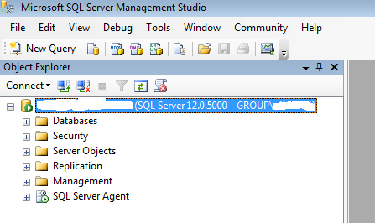

3. Expand Databases, right-click the database from which to add the files, and then click Properties.

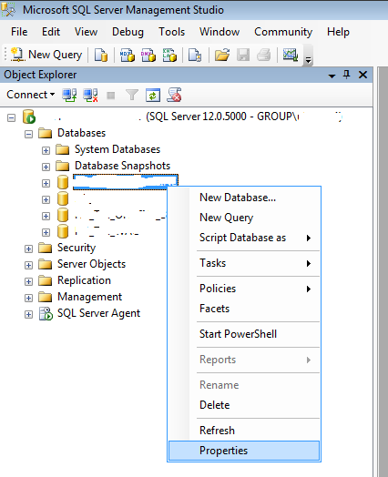

4.In the Database Properties dialog box, select the Files page. To add a data or transaction log file, click Add.

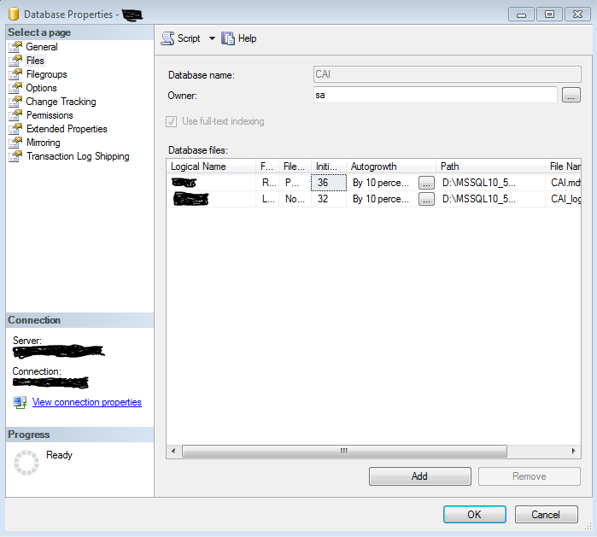

5.In the Database files grid, enter a logical name for the file. The file name must be unique within the database and Select the file type, data or log. For a data file, select the filegroup in which the file should be included from the list, or select <new filegroup> to create a new filegroup. Transaction logs cannot be put in filegroups.

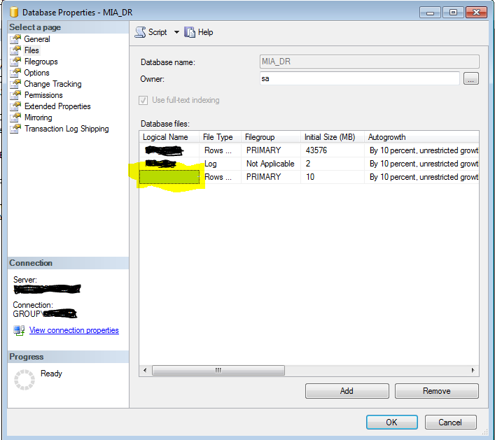

8. Specify the initial size of the file. Make the data file as large as possible, based on the maximum amount of data you expect in the database.

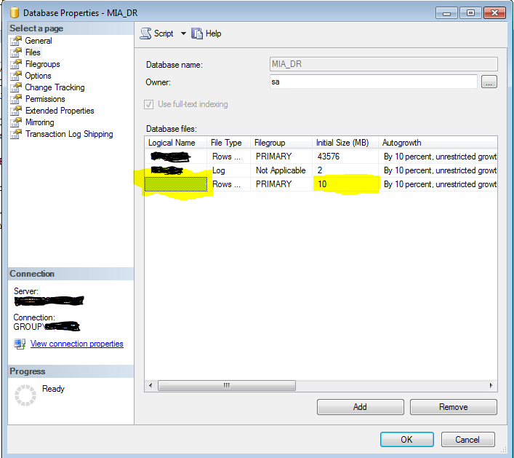

9. To specify how the file should grow, click (…) in the Autogrowth column. Select from the following options:



- To allow for the currently selected file to grow as more data space is required, select the Enable Autogrowth check box and then select from the following options:
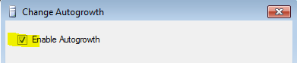

- To specify that the file should grow by fixed increments, select In Megabytes and specify a value.

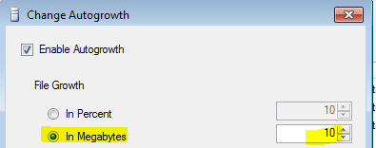
- To specify that the file should grow by a percentage of the current file size, select In Percent and specify a value.

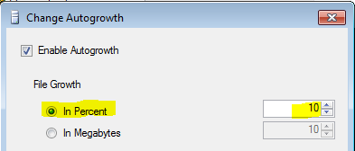

10. To specify the maximum file size limit, select from the following options:
- To specify the maximum size the file should be able to grow to, select Restricted File Growth (MB) and specify a value.
- To allow for the file to grow as much as needed, select Unrestricted File Growth.
- To prevent the file from growing, clear the Enable Autogrowth check box. The size of the file will not grow beyond the value specified in the Initial Size (MB) column.

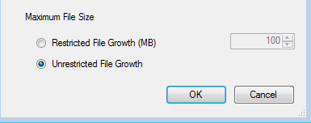
11. Specify the path for the file location. The specified path must exist before adding the file.

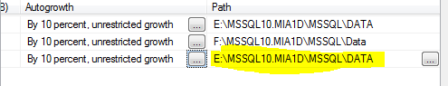

12. Click OK.

4.Security

Permissions
Requires ALTER permission on the database.

5.Limitations and Restrictions
1.You cannot add or remove a file while a BACKUP statement is running.
2.A maximum of 32,767 files and 32,767 file groups can be specified for each database.

6.Reference
- https://technet.microsoft.com/en-us/library/ms189253(v=sql.110).aspx

